**Forum Page UI Design**

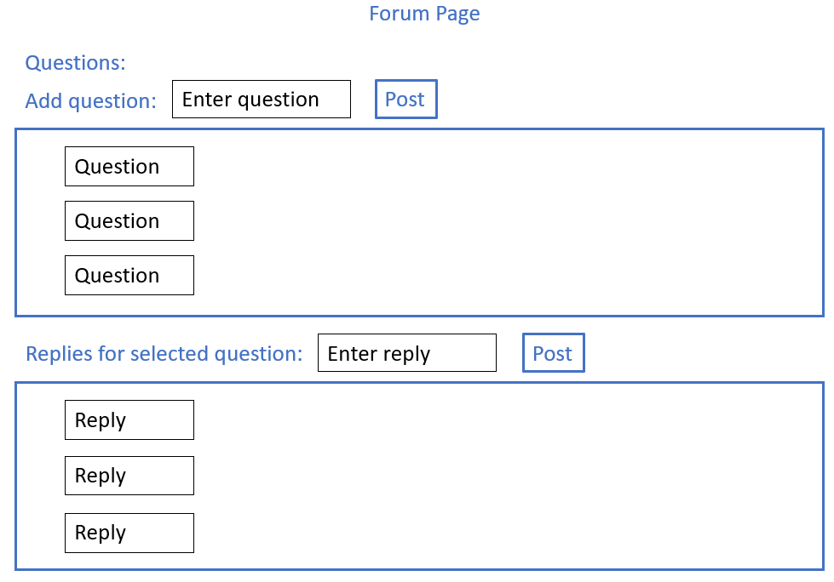Figure 1:

Figure 1 shows a potential UI design that could be used as it is very efficient and user friendly way to communicate between members.